AUTOMATIC LICENSE NUMBER PLATE RECOGNITION
A Project Report
Submitted in partial fulfillment of the requirements for the award of the degree of
BACHELOR OF TECHNOLOGY
In
COMPUTER SCIENCE AND ENGINEERING (AIML)
By
SOMESTHREE RAMKUMAR | 21VD5A6612
GANGINENI SRI VAISHNAVI | 20VD1A6652
BANGARI SHANMUKH | 20VD1A6639
KOREM DIVYA SRI | 20VD1A6613

Under the guidance of
Mr. G. SRIDHAR
Assistant Professor
Department of Computer Science and Engineering.

DEPARTMENT OF COMPUTER SCIENCE AND ENGINEERING (AIML)
JAWAHARLAL NEHRU TECHNOLOGICAL UNIVERSITY HYDERABAD
UNIVERSITY COLLEGE OF ENGINEERING MANTHANI
Centenary Colony, Pannur (Vill), Ramagiri (Mdl), Peddapalli-505212, Telangana (India).
2023-2024

JAWAHARLAL NEHRU TECHNOLOGICAL UNIVERSITY HYDERABAD UNIVERSITY COLLEGE OF ENGINEERING MANTHANI

DEPARTMENT OF COMPUTER SCIENCE AND ENGINEERING (AIML)
DECLARATION BY THE CANDIDATE
We,
SOMESTHREE RAMKUMAR | 21VD5A6612
GANGINENI SRI VAISHNAVI | 20VD1A6652
BANGARI SHANMUKH | 20VD1A6639
KOREM DIVYA SRI | 20VD1A6613
hereby declare that the project report entitled “AUTOMATIC LICENSE NUMBER PLATE RECOGNITION” under the guidance of Mr. G. SRIDHAR, Assistant Professor, Department of Computer Science and Engineering, JNTUH University College of Engineering Manthani submitted in partial fulfillment for the award of the Degree of Bachelor of Technology in Computer Science and Engineering (AIML).
This is a record of bonafide work carried out by us and the results embodied in this project report have not been reproduced or copied from any source. The results embodied in this project have not been submitted to any other University or Institute for the award of any degree or diploma.
SOMESTHREE RAMKUMAR | 21VD5A6612
GANGINENI SRI VAISHNAVI | 20VD1A6652
BANGARI SHANMUKH | 20VD1A6639
KOREM DIVYA SRI | 20VD1A6613

JAWAHARLAL NEHRU TECHNOLOGICAL UNIVERSITY HYDERABAD UNIVERSITY COLLEGE OF ENGINEERING MANTHANI

DEPARTMENT OF COMPUTER SCIENCE AND ENGINEERING (AIML)
CERTIFICATE
This is to certify that the project report entitled “AUTOMATIC LICENSE NUMBER PLATE RECOGNITION” being submitted by
SOMESTHREE RAMKUMAR | 21VD5A6612
GANGINENI SRI VAISHNAVI | 20VD1A6652
BANGARI SHANMUKH | 20VD1A6639
KOREM DIVYA SRI | 20VD1A6613
in the partial fulfillment of the requirements for the award of the Degree of BACHELOR OF TECHNOLOGY in Computer Science and Engineering (AIML) to the JAWAHARLAL NEHRU TECHNOLOGICAL UNIVERSITY HYDERABAD UNIVERSITY COLLEGE OF ENGINEERING MANTHANI is a record of bonfide work carried out by them under my guidance and supervision.
The results of investigation enclosed in this report have been verified and found satisfactory. The results embodied in this project report have not been submitted to any other University or Institute for the award of any degree or diploma.

SUPERVISER | HEAD OF THE DEPARTMENT
Mr. G. Sridhar, Assistant Professor
EXTERNAL EXAMINAR
DATE:

ACKNOWLEDGMENT
We express our sincere gratitude to Dr. Ch. Sridhar Reddy, Professor of Mechanical Engineering, Principal & Head of the department of Computer Science and Engineering (AIML), JNTUH University College of Engineering Manthani for encouraging and giving permission to accomplish our project successfully.
We express our profound gratitude and thanks to our project guide Mr. G. Sridhar, Assistant Professor, CSE Department, JNTUH University College of Engineering Manthani for his constant help, personal supervision, expert guidance, and consistent encouragement throughout this project which enabled us to complete our project successfully in time.
We also take this opportunity to thank other faculty members of CSE Department for their kind co-operation.
We wish to convey our thanks to one and all those who have extended their helping hands directly and indirectly in completion of our project.
SOMESTHREE RAMKUMAR | 21VD5A6612
GANGINENI SRI VAISHNAVI | 20VD1A6652
BANGARI SHANMUKH | 20VD1A6639
KOREM DIVYA SRI | 20VD1A6613

ABSTRACT
A
utomatic license number plate recognition (ALNPR) is an essential technology for intelligent transportation and traffic management systems. The aim of ALNPR systems is to detect vehicles, capture images of them, extract the license plate region from images through segmentation methods, and utilize Optical Character Recognition (OCR) techniques to accurately recognize the characters on license plates. ALNPR has diverse applications in transportation infrastructure, including electronic toll collection, traffic law enforcement, parking access control, and vehicle tracking. In this project, the model introduces an affine transformation module to rectify tilted license plates in images before recognition. For computational efficiency, the recognition model Inception ResNet V2 architectures use depth wise separable convolutions for deep representation learning with modest parameters. The license plate number extracted through the ALNPR system can be used to query a database containing vehicle records. By matching the recognized license plate to database entries, additional specific information associated with that vehicle can be retrieved. This information may include the chassis number, details regarding the registered owner, current insurance details, and more.
The advanced vehicle identification systems with potential applications in various domains, contributing to enhanced security and efficient management of vehicular activities. The performance of the system is tested on real images, demonstrating its practical viability and reliability in real-world scenarios.
Keywords: license plate, image processing, detection, recognition, convolutional neural network, CNN, faster R-CNN, optical character recognition, OCR, Inception ResNetV2.

TABLE OF CONTENTS
S.No. | CONTENTS |  | PAGE No.
i. | TITLE PAGE |  | i
ii. | DECLARATION PAGE |  | ii
iii. | CERTIFICATE |  | iii
iv. | ACKNOWLEDGMENT |  | iv
v. | ABSTRACT |  | v
vi. | LIST OF TABLES |  | ix
vii. | LIST OF FIGURES |  | x
1 | INTRODUCTION |  | 1
 | 1.1 Overview |  | 2
 | 1.2 Motivation |  | 2
 | 1.3 Objective |  | 3
 | 1.4 Problem Statement |  | 3
2 | LITERATURE SURVEY |  | 4
 | 2.1 Deep Learning Architecture |  | 6
 | 2.2 Convolutional Neural Network |  | 7
 | 2.3 History of Image Processing |  | 8
 | 2.4 Application |  | 9
3 | SYSTEM ANALYSIS |  | 10
 | 3.1 Existing System |  | 11
 | 3.2 Proposed Solution |  | 11
 | 3.3 Feasibility of Study |  | 11
 | 3.4 Methodology of Proposed System |  | 13
4 | SYSTEM REQUIREMENT SPECIFICATION |  | 15
 | 4.1 Functional Requirements |  | 15
 | 4.2 Non-Functional Requirements |  | 15
 | 4.3 Hardware Requirements |  | 17
 | 4.4 Software Requirements |  | 17
5 | SYSTEM DESIGN |  | 19
 | 5.1 Concept of UML |  | 20
 | 5.2 UML Diagrams |  | 21
 |  | 5.2.1 Use Case Diagram | 22
 |  | 5.2.2 Sequence Diagram | 23
 |  | 5.2.3 Class Diagram | 24
 | 5.3 Data Flow Diagram |  | 25
 | 5.4 Project Architecture |  | 26
6 | IMPLEMENTATION |  | 29
 | 6.1 Working Description |  | 29
 | 6.2 Deep Learning for Object Detection |  | 29
 | 6.3 Sample Code |  | 31
7 | TESTING |  | 34
 | 7.1 Introduction to Testing |  | 35
 | 7.2 Types of Software Testing |  | 36
 | 7.3 Test Cases |  | 37
8 | RESULT |  | 38
9 | CONCLUSION |  | 41
10 | BIBLOGRAPHY |  | 43

LIST OF FIGURES
FIG.NO | FIGURE NAME | PAGE
2.1.1 | Deep Learning Architecture | 6
2.2.1 | CNN Architecture | 7
2.4.1 | Applications of ALNPR | 9
3.4.1 | Workflow of Proposed ALNPR | 13
5.2.1.1 | Use Case Diagram | 22
5.2.2.1 | Sequence Diagram | 23
5.2.3.1 | Class Diagram | 24
5.3.1 | Data Flow Diagram | 25
5.4.1 | Inception ResNet-V2 Architecture | 25
5.5.1 | Project Architecture | 26
8.1 | Home Page | 39
8.2 | Upload Image and Extracted Number Plate | 40
8.3 | Details of Number Plate | 40

LIST OF TABLES
TABLE NO. | TABLE NAME | PAGE NO.
7.3.1 | Test Cases | 37

INTRODUCTION

- INTRODUCTION
1.1 OVERVIEW
Automatic License Number Plate Recognition (ALNPR) represents a pivotal technological advancement in the domain of intelligent transportation and traffic management. This cutting-edge system is designed to autonomously detect, capture, and interpret license plate information from vehicles. The fundamental objective of ALNPR is to streamline and enhance various aspects of transportation infrastructure, introducing efficiency and intelligence into tasks such as toll collection, traffic law enforcement, parking access control, and vehicle tracking. ALNPR systems operate through a sequence of sophisticated processes. Initially, they employ vehicle detection mechanisms to identify and locate vehicles within a given environment. Subsequently, high-resolution images of these vehicles are captured, and advanced image segmentation techniques are applied to isolate and extract the specific region containing the license plate. Optical Character Recognition (OCR) technologies are then deployed to precisely decipher the alphanumeric characters on the license plate. One notable innovation in ALNPR is the incorporation of an affine transformation module, enabling the rectification of tilted license plates in images before the recognition process.
The proposed model contributes to increased accuracy in character identification. Moreover, for computational efficiency, ALNPR systems often leverage architectures like Inception ResNet V2, utilizing depth-wise separable convolutions for optimal deep representation learning with modest parameter requirements. The implications of ALNPR extend beyond mere license plate recognition. The system allows for the seamless querying of a database containing comprehensive vehicle records. By matching the recognized license plate to database entries, ALNPR systems provide access to specific information associated with the vehicle, including chassis numbers, details of the registered owner, current insurance information, and more. This method sets the stage for exploring the multifaceted applications and technological intricacies of ALNPR, illustrating its crucial role in advancing the efficiency and security of modern transportation systems.
1.2 MOTIVATION
The main motivation behind the development of this ALNPR project was to create an automated system for vehicle identification and tracking. This technology enables effective monitoring and management of traffic flow through image-based license plate recognition. ALNPR has widespread applications in transportation infrastructure including electronic toll collection, parking access control, and law enforcement. An accurate and robust ALNPR system could greatly benefit smart transportation systems and security agencies.
1.3 OBJECTIVE
- The primary objective is to accurately recognize the license plate characters under different environments and imaging conditions. The system should be robust to challenges like motion blur, low light, shadows, occlusion etc.
- The system should recognize license plates at high speeds in real-time for applications like electronic toll collection, traffic monitoring and law enforcement.
- Easy reconfiguration for new formats is required without extensive retraining.
1.4 PROBLEM STATEMENT
Automatic license plate recognition (ALPR) in uncontrolled environments is an extremely challenging computer vision task. The absence of a standardized format, characterized by variations in fonts, sizes, colors, and additional decorations, complicates the localization and segmentation of license plates. The exponential growth in vehicles exacerbates the challenge of effectively managing and monitoring traffic density in daily life. Furthermore, the widespread use of security cameras supplying low-resolution video feeds presents obstacles for accurate character recognition. Addressing these issues is imperative to enhance the efficacy of Automatic License Number Plate Recognition (ALNPR) systems in coping with the evolving dynamics of modern transportation systems.

LITERATURE SURVEY

- LITERATURE SURVEY
A systematic and thorough search of all types of published literature as well as other sources including dissertations, theses to identify as many items as possible that are relevant to a particular topic.
In recent years, Convolutional Neural Networks (CNNs) have become the dominant technique used in automatic license plate recognition (ALPR) systems due to their capabilities in tasks like detection, recognition, and classification. Typical ALPR pipelines involve image acquisition via cameras and sensors, pre-processing steps like filtering and binarization to prepare images, followed by the core CNN processing which includes license plate detection using models like Faster R-CNN (Inception ResNetV2), segmentation to isolate characters using morphological operations and bounding boxes, and finally optical character recognition by training CNNs to classify extracted characters, achieving over 90% accuracy. Overall, CNNs are well-suited for ALPR because of their trainable feature extraction layers which can effectively learn to identify license plate regions and recognize characters through supervised training procedures that augment datasets by randomly moving and resizing images to improve robustness and generalization capabilities to various positioning and angles.
When working on a number plate recognition project using OpenCV, TensorFlow, Pytesseract, and Flask, you will learn several concepts, tools, and frameworks:
- Web Development with Flask: Flask is a lightweight web application framework written in Python. It is designed to be easy to use and extend. Flask is used to create web servers and handle HTTP requests, making it suitable for building web applications and APIs.
- Video and Image Processing with OpenCV (cv2): OpenCV (Open-Source Computer Vision Library) is an open-source computer vision and machine learning software library. It provides tools for image and video analysis, including various computer vision algorithms and utilities.
- Machine Learning with TensorFlow/Keras: TensorFlow is an open-source machine learning framework, and Keras is an API that can run on top of TensorFlow. They are widely used for building and training deep learning models.
- Character Recognition with Pytesseract: Pytesseract is a Python wrapper for Google's Tesseract-OCR Engine. It is used for optical character recognition (OCR) to extract text from images. Pytesseract is widely employed in tasks such as document analysis, automated data entry, and text extraction from scanned documents. It supports multiple image formats, making it suitable for diverse applications.
- Data Handling with Pandas: Pandas is a powerful data manipulation library for Python. It provides data structures like Data Frames for efficient data handling and analysis.
- Integration of Tools: To integrate these different tools and frameworks into a complete license number plate recognition system. This includes preprocessing image input with OpenCV, detecting number plates with Pytesseract, classifying gestures with TensorFlow, and displaying the results with Flask.
These frameworks and libraries work together to create a system that takes an image of a license plate, performs object detection to locate the plate, extracts the text using OCR, and then uses Pandas for data manipulation and Flask for web application development.
2.1 DEEP LEARNING ARCHITECTURE
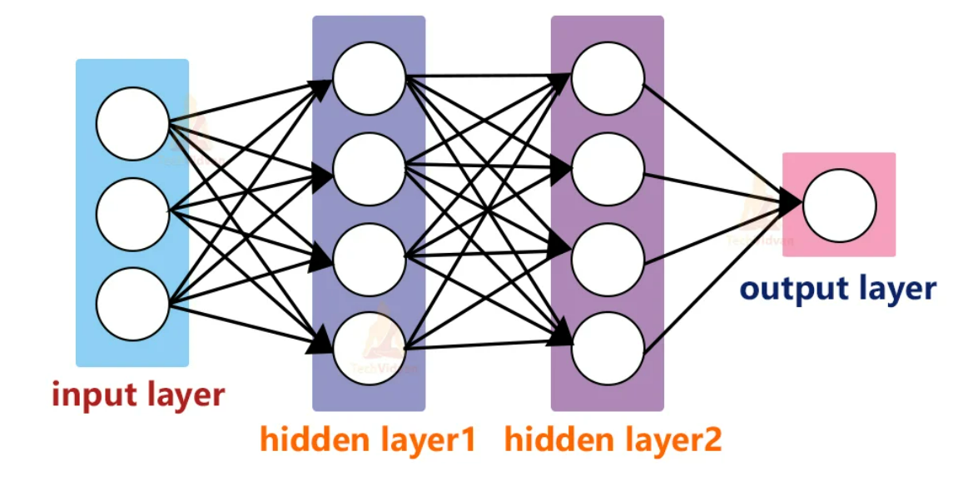
Fig 2.1.1 Deep Learning architecture
This architecture consists of Input layer, Hidden layer and output layer. Initially the data is taken from input layer, and it is given to hidden layer. Hidden layers are the artificial neurons where model learns from the data. Each neuron takes input from all neurons in previous layers, applies weight, sum them up and passes through activation function. As the data process through more layers of network, the features get more complex. The goal of neural network is to adjust weights to minimize difference between prediction and actual values.

2.2 CONVOLUTIONAL NEURAL NETWORKS(CNN)

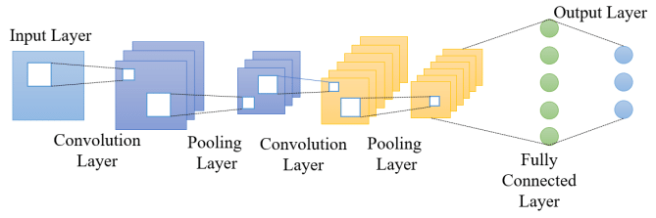
Fig 2.2.1 CNN Architecture
Convolutional Neural Network (CNN) architecture has following components:
- Input Layer: This is the layer where the network receives input from the dataset. It’s typically the raw pixel values of the image.
- Convolutional Layer: This layer performs a convolution operation, creating several smaller picture windows to go over the data.
- ReLU (Rectified Linear Unit) Layer: This layer applies the ReLU activation function elementwise. It replaces all negative pixel values in the feature map with zero. The purpose of this layer is to introduce non-linearity to the CNN.
- Pooling Layer: This layer reduces the spatial size (width and height) of the input volume. This serves to decrease the computational complexity, memory usage, and number of parameters.
- Fully Connected Layer: This layer is responsible for taking the results of the convolution/pooling process and using them to classify the image into a label (in a simple classification problem). It connects every neuron in one layer to every neuron in another layer.
- SoftMax or Logistic Layer: In the end, there will be a fully connected layer with the dimensions of the number of desired classes (in a classification problem, for example). This fully connected layer is fed into the SoftMax function for normalizing the output of the network to a probability distribution over predicted output class.

2.3 HISTORY OF IMAGE PROCESSING
Many of the techniques digital image processing, or digital picture processing as it often was called, were developed in the 1960s, at Bell Laboratories, the Jet Propulsion Laboratory, Massachusetts Institute of Technology, University of Maryland, and a few other research facilities, with application to satellite imagery, wire-photo standards conversion, medical imaging, videophone, character recognition, and photograph enhancement. The purpose of early image processing was to improve the quality of the image. It was aimed for human beings to improve the visual effect of people. In image processing, the input is a low-quality image, and the output is an image with improved quality. Common image processing includes image enhancement, restoration, encoding, and compression. The first successful application was the American Jet Propulsion Laboratory (JPL). They used image processing techniques such as geometric correction, gradation transformation, noise removal, etc. on the thousands of lunar photos sent back by the Space Detector Ranger 7 in 1964, taking into account the position of the sun and the environment of the moon. The impact of the successful mapping of the moon's surface map by the computer has been a huge success. Later, more complex image processing was performed on the nearly 100,000 photos sent back by the spacecraft, so that the topographic map, color map and panoramic mosaic of the moon were obtained, which achieved extraordinary results and laid a solid foundation for human landing on the moon.
The cost of processing was high, however, with the computing equipment of that era. That changed in the 1970s, when digital image processing proliferated as cheaper computers and dedicated hardware became available. This led to images being processed in real-time, for some dedicated problems such as television standards conversion. As general-purpose computers became faster, they started to take over the role of dedicated hardware for all but the most specialized and computer-intensive operations. With the fast computers and signal processors available in the 2000s, digital image processing has become the most common form of image processing and is generally used because it is not only the most versatile method, but also the cheapest.

2.4 APPLICATION
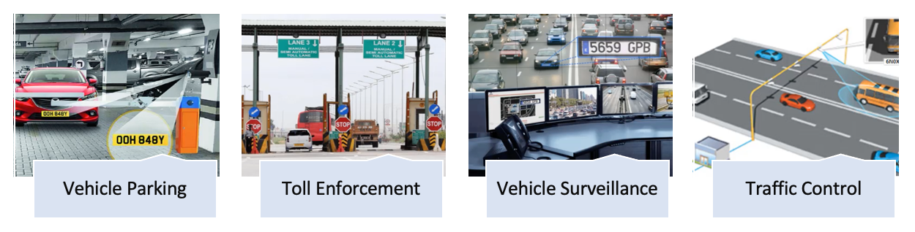
Fig .2.4.1. Applications of ALNPR
2.4.1 Traffic Management
ANPR is extensively used in traffic management systems to monitor and control vehicular movements on roads. It aids in regulating traffic flow, detecting violations, and optimizing signal control.
2.4.2 Law Enforcement
ANPR plays a crucial role in law enforcement by automatically identifying and tracking vehicles involved in criminal activities. It assists in the detection of stolen vehicles, wanted individuals, and vehicles associated with illegal activities.
2.4.3 Parking Management
ANPR is employed in parking facilities for automated entry and exit control. It streamlines the parking process by automatically recognizing and validating license plates, facilitating efficient management of parking spaces.
2.4.4 Electronic Toll Collection
ANPR is integrated into electronic toll collection systems, enabling seamless and automated toll payments. It enhances the efficiency of toll booths by eliminating the need for manual transactions.

SYSTEM ANALYSIS

- SYSTEM ANALYSIS
A System Analysis is a method for identifying and solving problems that looks at each component in the overall system for the purpose of achieving specific goals.
3.1 EXISTING SYSTEM
The Existing system uses histogram equalization, median filters, Sobel edge detection, projection analysis for license plate detection and it uses color difference formulas and morphological operations for plate segmentation and employ support vector machines (SVM) for character recognition, the existing system have limitations in handling challenging real-world conditions like lighting variations, occlusion, low resolution images and number plate variations etc.
3.2 PROPOSED SOLUTION
The proposed automatic number plate recognition (ANPR) system adopts a deep convolutional neural network (CNN) based on the Inception ResNetV2 architecture, utilizing depth wise separable convolutions for efficient yet accurate feature extraction. Data normalization during preprocessing enhances model convergence, and rectangular bounding boxes are employed for precise license plate labeling and detection. With a custom dataset of 500 images, the system achieves an 85% accuracy in number plate detection, leveraging the pytesseract module for character recognition from cropped license plates. Claiming reliability under diverse conditions, the system aims to overcome limitations observed in previous academic and commercial ANPR systems.
  - FEASIBILITY STUDY
3.3.1 Technical Feasibility
The technical feasibility of implementing an Automatic License Plate Number Recognition (ALPR) system using OpenCV, InceptionResNetV2, and Pytesseract is high. OpenCV provides robust tools for image processing, allowing efficient manipulation and analysis of vehicle images. InceptionResNetV2, a state-of-the-art deep learning model, serves as a powerful feature extractor for plate localization and character segmentation, leveraging its capabilities for object detection. The use of transfer learning with pretrained InceptionResNetV2 models on ImageNet expedites model development. Pytesseract, an optical character recognition library, seamlessly integrates with the system for accurate character recognition. The combination of these technologies enables a comprehensive ALPR pipeline, from image acquisition to database lookup, fostering real-world applications in traffic monitoring and law enforcement. The modular and interoperable nature of these technologies ensures a technically feasible and efficient solution for automatic license plate recognition.
3.3.2 Schedule Feasibility
The schedule feasibility for implementing an Automatic License Plate Number Recognition (ALPR) system using OpenCV, InceptionResNetV2, and Pytesseract appears promising. Leveraging the well-established functionalities of OpenCV for image processing provides a solid foundation, expediting the initial stages of the project. InceptionResNetV2, being a pretrained model, accelerates development by reducing the time required for training and fine-tuning. Integrating Pytesseract for character recognition complements the workflow seamlessly. However, potential challenges may arise in fine-tuning the models and optimizing the system for specific use cases. A realistic schedule should allocate time for iterative testing, debugging, and optimization, ensuring the reliability and accuracy of the ALPR system. Overall, with careful planning and an agile development approach, meeting project milestones and deadlines within a reasonable timeframe is feasible.
3.3.3 Economic Feasibility
The economic feasibility of implementing an Automatic License Plate Number Recognition (ALPR) system using OpenCV, InceptionResNetV2, and Pytesseract is favorable. OpenCV, being an open-source library, significantly reduces development costs by providing a comprehensive suite of tools for image processing without licensing fees. The use of InceptionResNetV2 for deep learning leverages transfer learning, allowing for efficient model training on specific ALPR tasks, minimizing the need for extensive computational resources. Pytesseract is an open-source OCR library, contributing to cost-effectiveness. Additionally, the modular nature of the proposed system allows for scalability, enabling integration with existing infrastructure and minimizing the need for costly hardware upgrades. The economic feasibility is further enhanced by the potential for streamlined maintenance and updates. Overall, the combination of these cost-effective technologies makes the implementation of an ALPR system economically viable for various applications, including traffic management and law enforcement.

  - METHODOLOGY OF PROPOSED SYSTEM
Fig .3.4.1 Workflow of Proposed ALNPR
- Image Acquisition and Annotation: Image acquisition is the process of capturing images from various sources such as cameras or datasets. In the context of automatic license plate recognition (ALPR), it involves obtaining images containing vehicles with visible license plates. These images serve as input data for subsequent stages in the ALPR system.
- Data Preprocessing: In the data preprocessing stage, the captured images are loaded and converted into NumPy arrays. Standardization is achieved by resizing the images to a common dimension, such as 224x224 pixels. Normalizing pixel values between 0 and 1 is performed, enhancing the model's ability to generalize across diverse image conditions. This step prepares the data for efficient processing by deep learning models.
- Plate Localization (Using Inception ResNetV2: The InceptionResNetV2 model, pretrained on ImageNet, serves as a feature extractor. Additional convolutional layers are added on top to specialize in license plate detection. The model is trained to predict the coordinates of license plates in the images, effectively localizing the region containing the license plate. This stage is crucial for accurate identification and segmentation.
- Character Segmentation (Using Inception ResNetV2): Following plate localization, InceptionResNetV2 is repurposed to segment individual characters within the detected license plate region. Sub-models based on InceptionResNetV2 can be employed to detect the locations of individual characters. This step sets the stage for precise character recognition in the subsequent phase.
- Character Recognition (Using Pytesseract OCR): Character recognition involves extracting each segmented character image and utilizing the Pytesseract OCR library for optical character recognition. Pytesseract interprets the textual information from the characters. Post-processing steps are applied to clean up any artifacts, ensuring accurate and reliable recognition of the license plate characters.
- Database Lookup: The recognized license plate text is utilized to query a vehicle information database. This database stores mappings between license plate numbers and associated vehicle metadata, such as owner information. Authorities can then retrieve relevant details for registered vehicles, enabling applications like traffic monitoring, suspect tracking, and law enforcement. The integration with a database enhances the ALNPR system's practical utility in real-world scenarios.

SYSTEM REQUIREMENT SPECIFICATION

- SYSTEM REQUIREMENT SPECIFICATION
System Requirements Specification plays an important role in creating quality software solutions. Specification is basically a representation process. Requirements are represented in a manner that ultimately leads to successful software implementation. Requirements may be specified in a variety of ways. However, there are some guidelines worth following:
- Representation format and content should be relevant to the problem.
- Information contained within the specification should be nested.
- Diagrams and other notational forms should be restricted in number and consistent in use.

4.1 FUNCTIONAL REQUIREMENTS
Functional requirements are product features or functions that developers must implement to enable users to accomplish their tasks. So, it’s important to make them clear both for the development team and the stakeholders. Generally, functional requirements describe system behavior under specific conditions.
4.2 NON-FUNCTIONAL REQUIREMENTS
- Usability
Usability is the case of use and learns ability of a human-made object. The object of use can be a software application, website, book, tool, machine, process, or anything a human interacts with. A usability study may be conducted as a primary job function by a usability analyst or as a secondary job function by designers, technical writers, marketing personnel, and others.
- Reliability
The probability that a component part, equipment, or system will satisfactorily perform its intended function under given circumstances, such as environmental conditions, limitations as to operating time, and frequently and thoroughness of maintenance for a specified period.
- Performance
Accomplishment of a given task measured against present standards of accuracy, completeness, cost, and speed.
- Supportability
To which the design characteristics of a standby or support system meet the operational requirements of an organization.
- Implementation
Implementation is the realization of an application, or execution of a plan, idea, model, design, specification, standard, algorithm, or policy.
- Interface
An interface refers to a point of interaction between components and is applicable at the level of both hardware and software. This allows a component whether a piece of hardware such as a graphics card or a piece of software such as an internet browser to function independently while using interfaces to communicate with other components via an input/output system and an associated protocol.
- Legal
It is established by or founded upon law or official or accepted rules of or relating to jurisprudence: "legal loophole". Having legal efficacy or force", "a sound title to the property" Relating to or characteristic of the profession of law, "the legal profession". Allowed by official rules; "a legal pass receiver".
4.3 HARDWARE REQUIREMENTS
4.3.1 CPU SPECIFICATIONS
- CPU Type Intel Core i3 or more
4.3.2 MEMORY SPECIFICATIONS
- System Memory 8107MB (DDR4 SDRAM)
- Module Size 4 GB
- Memory Type DDR4 SDRAM
4.4 SOFTWARE REQUIREMENTS
4.4.1 OPERATING SYSTEM
- OS Name Microsoft Windows 11 Home Single Language
- OS Kernel Type Multiprocessor Free (64 bit)
    - SOFTWARE PACKS NEEDED
- Anaconda 3 (Tool comes with most of the required python packages along with python3 and Jupyter Notebook)
- Visual Studio-1.84.2
- Tesseract Engine (Must need to be installed)
    - FRAMEWORKS AND LIBRARIES
- pyqt5 - 5.14.1
- lxml - 4.9.1
- tensorflow - 2.13.0
- Flask - 3.0.0
- Flask-SQLAlchemy - 3.1.1
- opencv-python - 4.8.1.78
- pytesseract - 0.3.10
- scipy - 1.11.3
- scikit-learn – 1.3.0

SYSTEM DESIGN

- SYSTEM DESIGN

System design is the process of defining the elements of a system such as the architecture, modules and components, the different interfaces of those components and the data that goes through that system. It is meant to satisfy specific needs and requirements through the engineering of a coherent and well-running System.

5.1 CONCEPT OF UML
Unified Modeling Language (UML) is a standardized visual modeling language used in the field of software engineering to express, document, design, and communicate software systems. UML provides a set of graphical notations and a framework for representing the structure and behavior of systems, making it a powerful tool for modeling complex software architectures. Here are some key concepts associated with UML.
1. Diagrams
UML consists of several types of diagrams, each serving a specific purpose. Common diagram types include:
- Class Diagrams: Represent the static structure of a system by illustrating classes, their attributes, methods, and relationships.
- Use Case Diagrams: Depict interactions between actors (users) and the system, capture different use cases and scenarios.
- Activity Diagrams: Visualize the dynamic aspects of a system, shows the flow of activities and actions.
- Sequence Diagrams: Display the chronological sequence of interactions between objects or components in a system.
- State Machine Diagrams: Illustrate the different states of an object and the transitions between those states.
2. Elements
UML defines various elements that can be used in diagrams. Common elements include:
- Class: Represents a blueprint for objects with common attributes and behaviors.
- Object: An instance of a class in a system.
- Actor An external entity interacting with the system.
- Use Case: A specific functionality or feature of a system as seen by an actor.
- Association: Represents relationships between classes or objects.

3. Relationships
UML provides a set of relationship types to define connections between elements. Common relationships include:
- Association: It describes how classes or objects are related to each other.
- Inheritance (Generalization): It illustrates the relationship between a general class (superclass) and a more specific class (subclass).
- Dependency: It represents a relationship where a change in one element may affect another.
- Aggregation and Composition: It describes how classes or objects are grouped together.
4. Behavioral and Structural views
UML allows for both behavioral and structural modeling. Behavioral diagrams, such as activity and sequence diagrams, focus on the dynamic aspects of a system, showcasing how it behaves over time. Structural diagrams, like class and object diagrams, emphasize the static structure of a system, highlighting its components and their relationships.
5. Standardization
UML is an industry-standard and is managed by the Object Management Group (OMG). Its standardized notation and semantics enable consistent and clear communication among software developers, architects, and other stakeholders involved in the software development process.
UML serves as a powerful tool for software engineers to design and communicate software systems in a standardized and visual manner.
5.2 UML DIAGRAMS

5.2.1 USE CASE DIAGRAM
A use case diagram in the Unified Modeling language (UML) is a type of behavioral diagram defined by and created from a Use-case analysis. Its purpose is to present a graphical overview of the functionality provided by a system in terms of actors, their goals (represented as use case), and any dependencies between those cases. The main purpose of a use case diagram is to show system functions are performed for which actor. Roles of the actors in the system can be depicted.
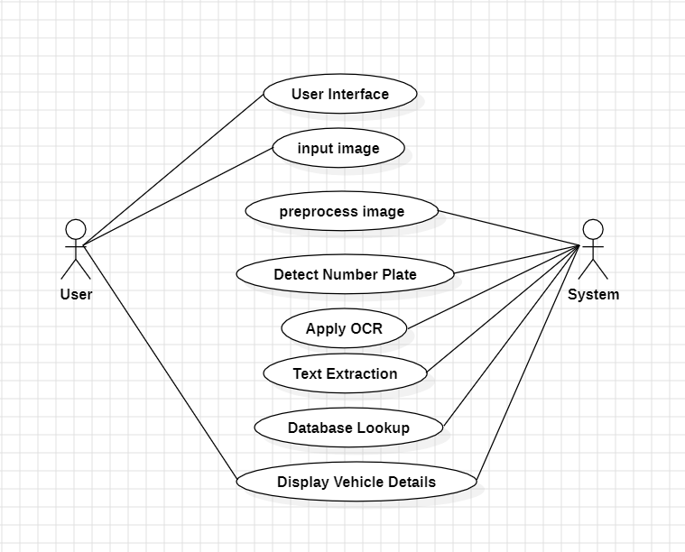
Fig 5.2.1.1 Use case diagram

Fig 5.2.1 shows the use case diagram of our system which describes the interaction between actors which are the ones will interact with the subjects. In our project there are mainly two actors involved in it namely User and System. In this diagram we will go to see the interaction involved with them.
5.2.2 SEQUENCE DIAGRAM
A sequence diagram in UML is a kind of interaction diagram which shows how each process of the system operates with one another and in what order. It is a constructed as a message sequence chart. Sequence diagrams are sometimes called event diagrams or timing diagrams.
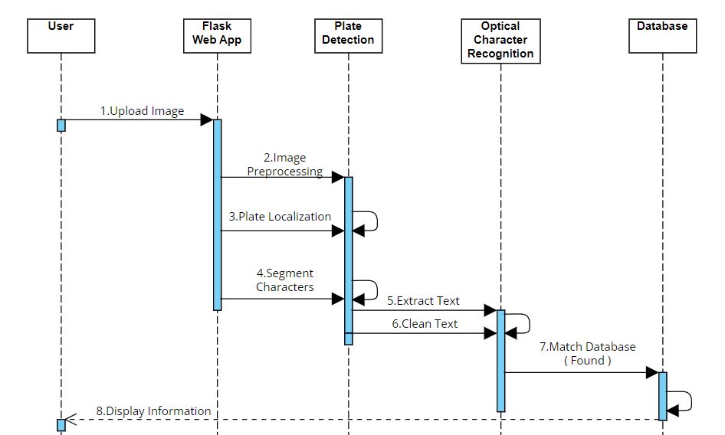
Fig 5.2.2.1 Sequence diagram
Fig 5.2.2 shows the Sequence diagram of our system which is an interaction diagram in which some sequence of information flows from one object to another object in a specified order to represent the time order of a process. It aims at a specific functionality of a model.
The sequence diagram outlines the interactions within an Automatic License Plate Recognition (ALPR) system. Initiated by the user through a Flask web application, the system undertakes a series of processes to recognize license plate information. The image undergoes preprocessing to enhance its quality before being forwarded to the Plate Localization module, which identifies and localizes the number plate. Subsequently, the system employs character segmentation to extract individual characters and patterns. Optical Character Recognition (OCR) using Pytesseract then translates the characters into alphanumeric text. The system cleanses the extracted text by removing unwanted characters using a regular expression system. The final step involves matching the processed text with a database, displaying vehicle details if a match is found, or indicating that details are not found. This sequence illustrates the orchestrated workflow of components, highlighting the integral role each plays in achieving efficient and accurate ALPR.
5.2.3 CLASS DIAGRAM
A class diagram is a visual representation in UML that depicts the structure and relationships among classes in an object-oriented system, illustrating attributes, methods, and associations. It showcases the blueprint of objects, their properties, and how they interact within a software application, aiding in system design and understanding.
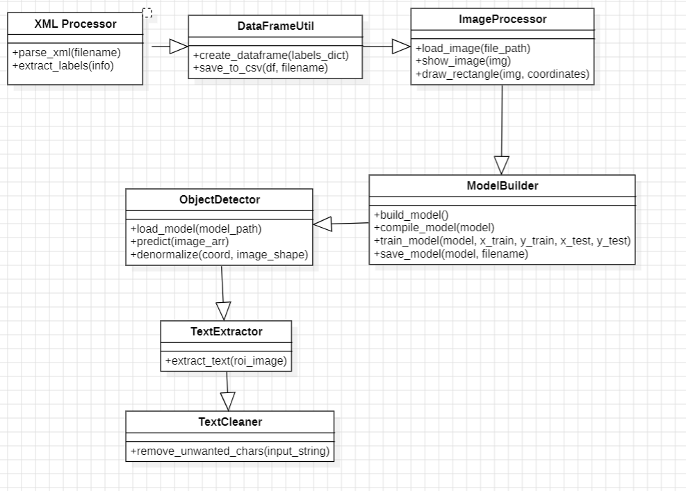
Fig 5.2.3.1 Class diagram
Fig .5.2.3.1 class diagram simplifies the structure for clarity. Depending on the actual implementation and the level of detail desired, additional classes and relationships may need to be included.
The class diagram encapsulates the key components and functionalities of the Automatic License Plate Recognition (ALPR) system. The XMLParser class is responsible for parsing XML files and extracting relevant data such as bounding box coordinates. The Object Detection class utilizes InceptionResNetV2 to detect and localize license plates within images. OCRProcessor manages the Optical Character Recognition process using Pytesseract, extracting alphanumeric text from license plate regions. Data Preprocessing handles data preprocessing tasks, ensuring images are properly formatted for model training. The ALPRSystem class orchestrates the overall system, integrating functionalities from XMLParser, Object Detection, OCRProcessor, and Data Preprocessing to run the ALPR process seamlessly. This class diagram illustrates the modular structure of the ALPR system, fostering a clear understanding of the relationships and responsibilities of each component.

5.3 DATA FLOW DIAGRAM
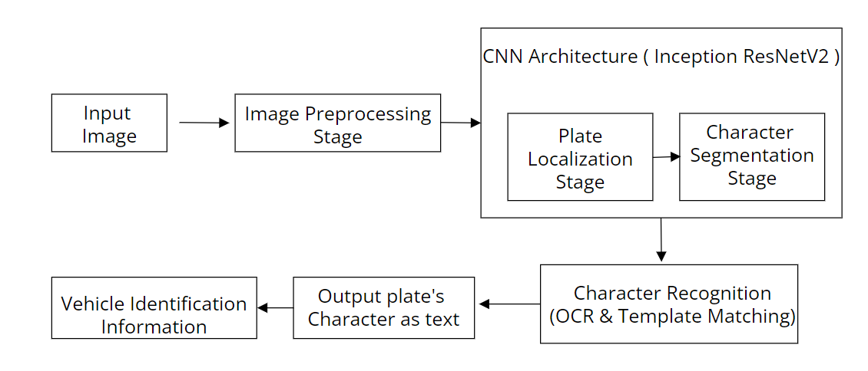
Fig .5.3.1 Data Flow Diagram
5.4 INCEPTION RESNET-V2 ARCHITECTURE
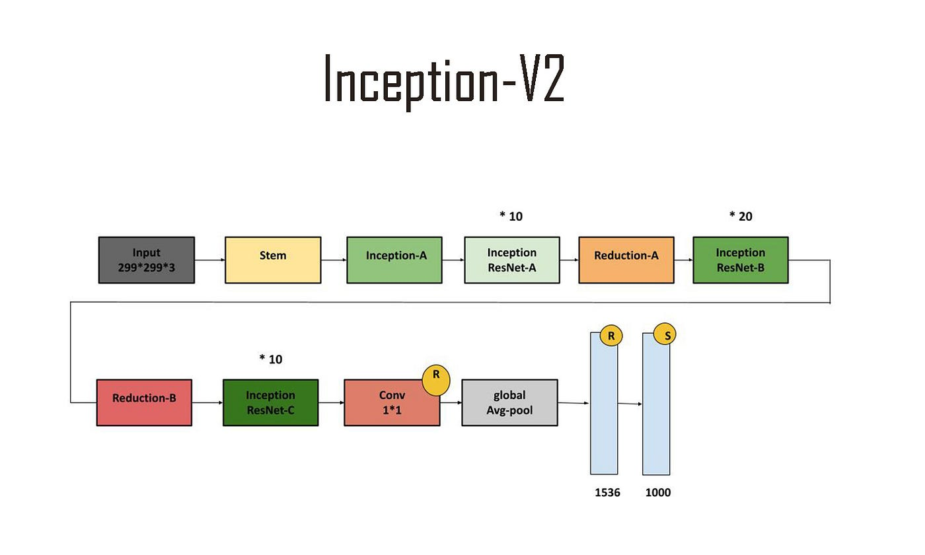
Fig .5.4.1 Inception ResNet-V2 Architecture
Inception-ResNetV2 is a deep neural network architecture that integrates ideas from two influential architectures: Inception and ResNet (Residual Networks). It was developed by researchers at Google as an extension of the original Inception architecture, aiming to further improve training convergence and classification accuracy, especially in very deep networks.
key components of Inception-ResNetV2:
- Inception Modules: Like the original Inception architecture, Inception-ResNetV2 uses inception modules to capture features at different spatial scales. These modules consist of multiple parallel convolutional filters with different receptive fields.
- Residual Connections: Residual connections are a crucial element borrowed from ResNet. These connections involve skipping one or more layers in the network, allowing the direct flow of information from earlier layers to later layers during both forward and backward passes. This helps mitigate the vanishing gradient problem and facilitates the training of very deep networks.
- Stem Block: The architecture starts with a stem block, which processes the input data and extracts basic features. The stem block typically includes a combination of convolutional layers, pooling, and normalization.
- Inception-ResNet Blocks: These blocks combine the multi-scale feature extraction of Inception modules with the residual connections of ResNet. This combination is aimed at leveraging the representational power of both architectures to enhance the overall performance.
- Reduction Blocks: Reduction blocks are employed to reduce the spatial dimensions of the feature maps, improving computational efficiency, and reducing the overall model complexity.
- Final Layers: The network concludes with global average pooling, fully connected layers, and a SoftMax activation for classification tasks.
5.5 PROJECT ARCHITECTURE
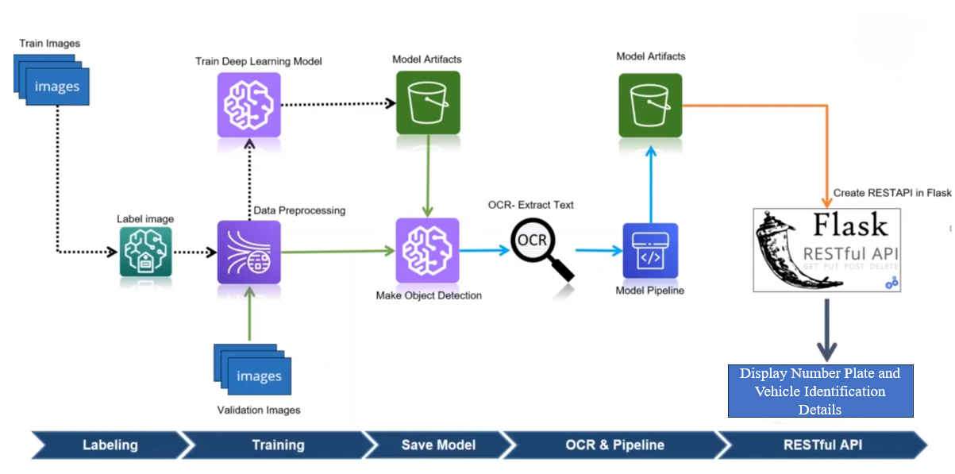Fig .5.5.1 Project Architecture
The architecture is divided into five main components: Labeling, Training, Save Model, OCR & Pipeline and Restful API.
1.Labeling:
Labelling is the initial phase of the ALPR system, involving the annotation of images with unique identifiers, typically alphanumeric codes, known as labels. In the context of ALPR using Inception ResNetV2, this process includes associating images of vehicles, specifically their license plates, with corresponding labels. Labelling is crucial for training the model to recognize distinctive features linked to license plates. Annotated datasets guide the model during the training phase, enabling it to learn and differentiate license plates in diverse real-world scenarios.
2.Training:
The training phase involves feeding the labelled dataset into the Inception ResNetV2 model, a pre-trained deep learning architecture known for efficient feature extraction. This phase refines the model's parameters through a process of iterative learning, allowing it to recognize intricate patterns and structures inherent to license plates. Training is fundamental to enhancing the model's ability to accurately identify and differentiate license plates within varying environmental conditions and image.
3.Save Model:
Upon successful completion of training, the Inception ResNetV2 model is saved to preserve the learned features and parameters. Saving the model allows for seamless integration into the ALPR pipeline during the detection and recognition phases. The saved model serves as a crucial component for the real-time identification of license plates, providing the system with the capability to make accurate predictions based on the knowledge acquired during the training process.
4.OCR & Pipeline:
The Optical Character Recognition (OCR) and pipeline phase involves leveraging the Inception ResNetV2 model to localize license plates in input images. The extracted license plate regions undergo segmentation to isolate individual characters. OCR techniques are then applied to recognize and interpret the alphanumeric characters on the license plate. This phase optimizes the input for accurate character extraction and interpretation, ensuring precise recognition of license plate information. The seamless integration of these processes into a cohesive pipeline enhances the ALPR system's overall efficiency and accuracy.
5.Flask RESTful API:
The ALPR system is made accessible through a Flask Restful API, providing a user-friendly interface for interactions. This API facilitates the upload of images, triggers the ALPR pipeline, and returns the recognized license plate information. The Flask Restful API ensures the deployment of the ALPR system as a web service, allowing users to interact with the system through HTTP requests. This approach enhances the system's versatility and accessibility, making it suitable for integration into various applications and platforms.

IMPLEMENTATION

- IMPLEMENTATION
6.1 WORKING DESCRIPTION
The Automatic License Plate Recognition (ALPR) system operates through a meticulously designed architecture comprising five crucial components. In the initial phase of Labeling, images of license plates are annotated with unique identifiers, paving the way for the training of the Inception ResNetV2 model. This model, renowned for its efficient feature extraction capabilities, undergoes an iterative Training phase, refining its parameters to recognize intricate patterns inherent to license plates in diverse real-world scenarios. Once trained, the Save Model component preserves the acquired knowledge for seamless integration into the ALPR pipeline during the subsequent Optical Character Recognition (OCR) & Pipeline phase.
During OCR & Pipeline, the Inception ResNetV2 model localizes license plates, extracts alphanumeric characters, and optimizes them for accurate interpretation. The system's versatility is heightened through the Flask RESTful API, providing a user-friendly interface for interactions. Users can upload images, triggering the ALPR pipeline, and receive recognized license plate information. Post extraction, the system compares the text with a database, displaying comprehensive vehicle details if a match is found. In cases where no match is identified, the system communicates that the vehicle details are not found. This architectural synergy enhances the ALPR system's overall efficiency and accessibility, making it adaptable for integration into diverse applications and platforms.

6.2 DEEP LEARNING FOR OBJECT DETECTION

6.2.1 INCEPTION-RESNET-V2 MODEL BUILDING
Inception-ResNet-v2 is a convolutional neural network that is trained on more than a million images from the ImageNet database. The network is 164 layers deep and can classify images into 1000 object categories, such as keyboard, mouse, pencil, and many animals. As a result, the network has learned rich feature representations for a wide range of images. The Inception-ResNet-v2 was used for the classification task. The architecture of the network is shown in Figure 9 . Inception-Resnet-v2 is formulated based on a combination of the Inception structure and the Residual connection. In the Inception-Resnet block multiple sized convolutional filters are combined by residual connections. The usage of reyfual connections not only avoids the degradation problem caused by deep structures but also reduces the training time.
Here we used the Inception-ResNet-v2 model with pre-trained weights and train this to our data. We are already import necessary libraries from TensorFlow previously, lets continue.
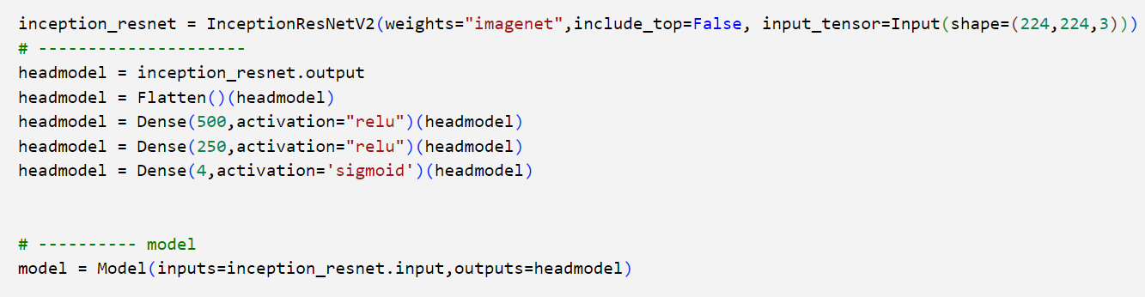
Now compile the model and have a look at our summary. Don't de surprise summary will be a bit massive. The summary is textual and includes information about: The layers and their order in the model. The output shape of each layer. The number of parameters (weights) in each layer.

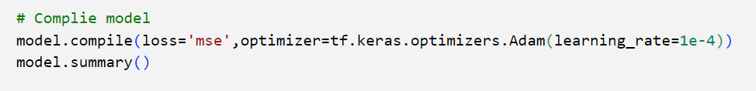

6.2.2 INCEPTION-RESNET-V2 TRAINING AND SAVE
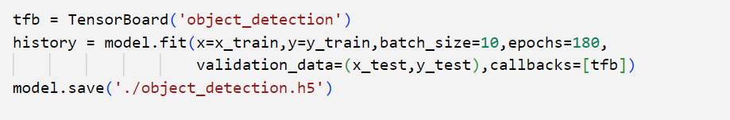
The code uses TensorBoard to visualize training metrics for an object detection neural network trained for 180 epochs on data (x_train, y_train) with batch size 10, and validates on (x_test, y_test). After training, the model is saved as 'object_detection.h5', facilitating performance analysis and future deployment in object detection.
6.3 SAMPLE CODE
import numpy as np
import cv2
import matplotlib.pyplot as plt
import tensorflow as tf
from tensorflow.keras.preprocessing.image import load_img, img_to_array
import pytesseract as pt
import re
model = tf.keras.models.load_model('./static/models/object_detection.h5')
def object_detection(path, filename):
# read image
image = load_img(path) # PIL object
image = np.array(image,dtype=np.uint8) # 8 bit array (0,255)
image1 = load_img(path,target_size=(224,224))
# data preprocessing
image_arr_224 = img_to_array(image1)/255.0 # convert into array and get the normalized output
h, w, d = image.shape
test_arr = image_arr_224.reshape(1,224,224,3)
# make predictions
coords = model.predict(test_arr)
# denormalize the values
denorm = np.array([w,w,h,h])
coords = coords * denorm
coords = coords.astype(np.int32)
# draw bounding on top the image
xmin, xmax, ymin, ymax = coords[0]
pt1 = (xmin, ymin)
pt2 = (xmax, ymax)
print(pt1, pt2)
cv2.rectangle(image, pt1,pt2, (0,255,0), 3)
# convert into bgr
image_bgr = cv2.cvtColor(image, cv2.COLOR_RGB2BGR)
cv2.imwrite('./static/predict/{}'.format(filename), image_bgr)
return coords
def remove_unwanted_chars(input_string):
# Remove whitespace and newline characters
clean_string = re.sub(r'\s+', '', input_string)
# Remove special characters
clean_string = re.sub(r'[^a-zA-Z0-9]+', '', clean_string)
return clean_string
def OCR(path, filename):
img = np.array(load_img(path))
cods = object_detection(path,filename)
xmin, xmax, ymin, ymax = cods[0]
roi = img[ymin:ymax, xmin:xmax]
roi_bgr = cv2.cvtColor(roi,cv2.COLOR_RGB2BGR)
cv2.imwrite('./static/roi/{}'.format(filename),roi_bgr)
text = pt.image_to_string(roi)
cleaned_text = remove_unwanted_chars(text)
print(cleaned_text)
return cleaned_text

TESTING

7. TESTING
7.1 INTRODUCTION TO TESTING
Software Testing is a method to check whether the actual software product matches expected requirements and to ensure that the software product is Defect free. It involves the execution of software/system components using manual or automated tools to evaluate one or more properties of interest.
The purpose of software testing is to identify errors, gaps, or missing requirements in contrast to actual requirements. Software Testing is Important because if there are any bugs or errors in the software, they can be identified early and can be solved before the delivery of the software product. A properly tested software product ensures reliability, security, and high performance which further results in timesaving, cost-effectiveness, and customer satisfaction. Software bugs can potentially cause monetary and human loss, and history is full of such examples. i)Starbucks was forced to close about 60 percent of stores in the U.S. and Canada due to software failure in its POS system. At one point, the store served coffee for free as they were unable to process the transaction. ii) Some of Amazon’s third-party retailers saw their product price reduced to 1p due to a software glitch. They were left with heavy losses. iii) Vulnerability in Windows 10. This bug enables users to escape from security sandboxes through a flaw in the win32k system. iv) In April of 1999, a software bug caused the failure of a $1.2 billion military satellite launch, the costliest accident in history.
7.2 TYPES OF SOFTWARE TESTING
Here are the software testing types:
Typically Testing is classified into three categories.
i) Functional Testing
ii) Non-Functional Testing or Performance Testing
iii) Maintenance
7.2.1 FUNCTIONAL TESTING
Functional testing deals with
i) Unit Testing
ii) Integration Testing
iii) System Testing
- Unit Testing: This software testing basic approach is followed by the programmer to test the unit of the program. It helps developers to know whether the individual unit of the code is working properly or not.
- Integration testing: It focuses on the construction and design of the software. You need to see whether the integrated units are working without errors or not.
- System testing: In this method, your software is compiled as a whole and then tested as a whole. This testing strategy checks functionality, security, and portability, among others.
7.2.2 NON-FUNCTIONAL TESTING
Non-functional Testing deals with
i) Performance
ii) Endurance
iii) Scalability
- Performance: Performance refers to the capability of a system to provide a certain response time. server a defined number of users or process a certain amount of data.
- Endurance: Endurance Testing is a type of Software Testing that is performed to observe whether an application can resist the processing load it is expected to have to endure for a long period. During endurance testing, memory consumption is considered to determine potential failures.
- Scalability: Scalability refers to the characteristic of a system to increase performance by adding additional resources.
7.2.3 MAINTENANCE
Maintenance deals with Regression, Maintenance
i) Regression
ii) Maintenance
- Regression: Regression testing is testing existing software applications to make sure that a change or addition hasn't broken any existing functionality.
- Maintenance: Software maintenance is a part of the Software Development Life Cycle.
7.3 TEST CASES
S.No. | Description | Input | Expected Results | Actual Results | Status
1 | Detect license plate in image with car at angle | Image with license plate MH15BD8877, car is at 30-degree angle to camera | Read license plate number as MH15BD8877 | MH15BD8877 | Success
2 | Recognize license plate with special characters | Image with license plate GJW-1-15-A-1138 | Read license plate GJW-1-15-A-1138 | GJW-1-15-A-1138 | Success
3 | Recognize blurred license plates | Image with blurred plate TN74AH1413 | Read available license plate TN74AH1413 | TN74AH1413 | Success
4 | Handle Different Plate Styles and Formats | Images with plates in various styles and formats GJW-1-15-A-1138 | Robust recognition across different styles, format as GJW-1-15-A-1138 | GJW-1-15-A-1138 | Success
5 | Integration with External Systems | ALNPR integrated into an excel sheet | Seamless integration and communication | Successful integration with excel sheet | Success
Table .7.3.1 Test Cases

RESULTS

8. RESULTS
To run the code use python app.py runserver in Anaconda prompt command. After clicking a webpage will be opened with the created interface. It looks like
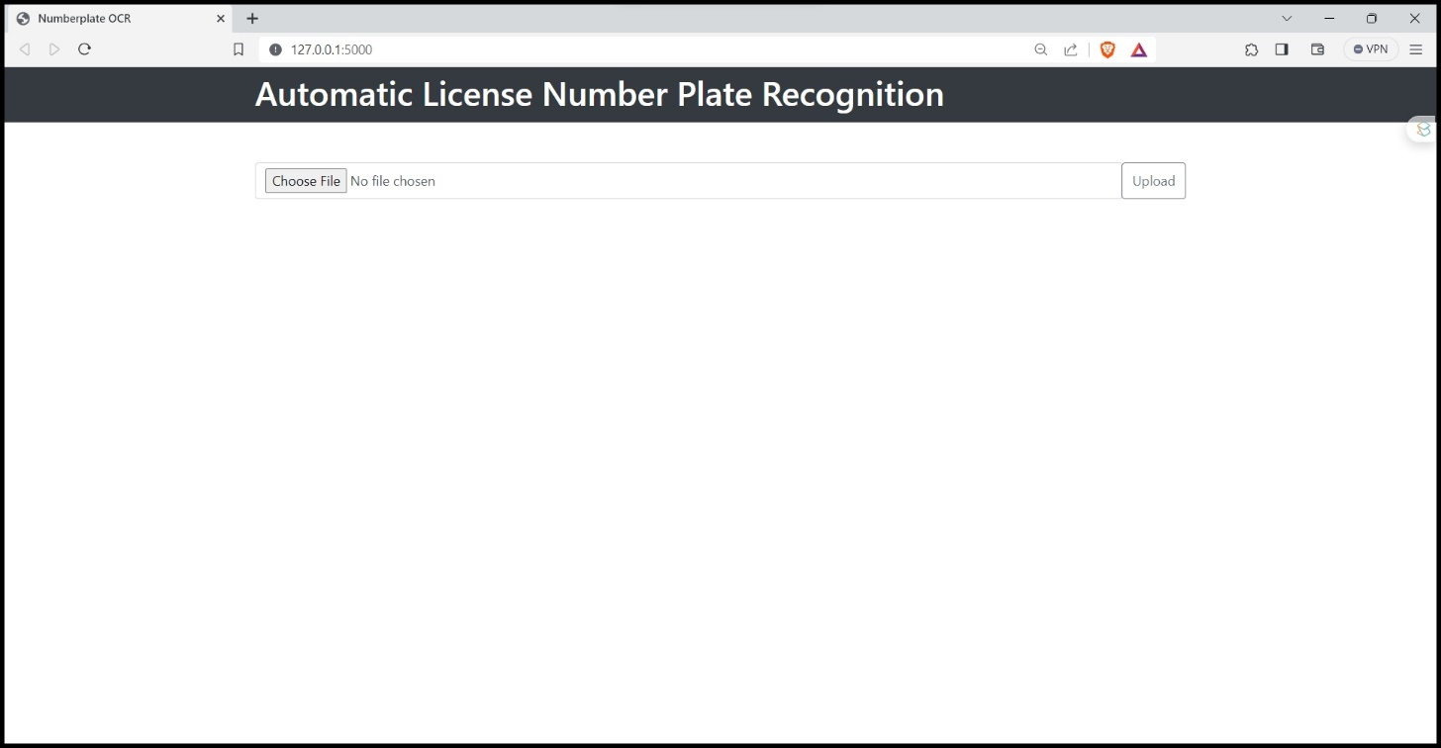
Fig .8.1 Home Page
Click the "Choose File" button to upload a vehicle image. The page will then display four frames: original image, bounding box on the number plate, cropped license plate, and extracted text; with a "Click here to get vehicle details" button below.
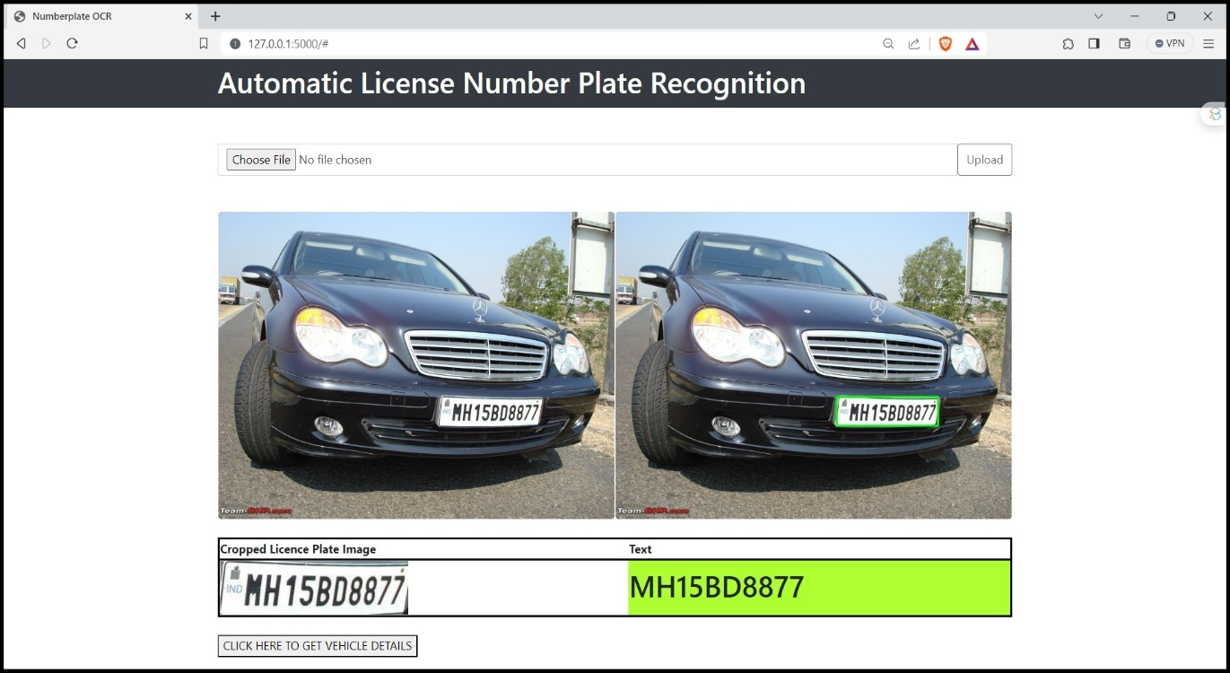
Fig .8.2. upload image and extracted number plate.
Upon clicking the "Click here to get vehicle details" button, the page will display information including the number plate, owner details, chassis number, insurance details, and more.
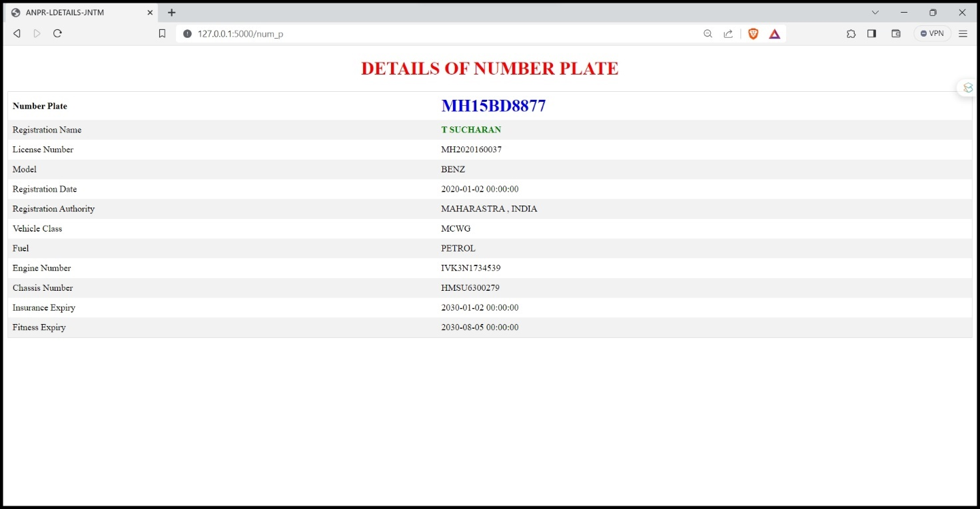
Fig .8.3. Details of Number Plate

CONCLUSION

9.CONCLUSION
Automatic License Number Plate Recognition is a pioneering development set to transform intelligent transportation infrastructure and improve efficiency in myriad aspects of traffic and vehicular management. By autonomously recognizing license plate information, ALNPR systems enable functionalities ranging from seamless electronic toll collection and parking access control to real-time vehicle tracking and law enforcement applications. The model achieved a strong plate detection accuracy of 85%. This approach enabled robust recognition across varying plate fonts and styles with an accuracy of 80%.
Overall, the system will deliver numerous beneficial applications like automated toll collection, parking access control, and real-time vehicle tracking. The technology also assists law enforcement in functions such as stolen vehicle recovery and suspect apprehension while enabling streamlined traffic violation issuing and it promises improved transportation infrastructure security and efficiency.
Future Enhancements:
- Today advances technology took Automatic Number Plate Recognition (ANPR) systems from hard to set up, limited expensive, fixed based applications to simple mobile ones in which “point to shoot” method can be used.
- This is possible because of the creation of software which runs on cheaper PC based and non-specialist hardware in which there is no need to give pre- defined direction, angels, speed and size in which the plate would be passing the camera field of view.
- Also, Smaller cameras which can read license plates at high speed, along with smaller, more durable processors that can fit in police vehicles, allowed law enforcement officers to patrol daily with the benefit of license plate recognition in real time.

BIBLOGRAPHY

10. BIBLOGRAPHY
[1] C.-H. Lin, Y.-S. Lin, and W.-C. Liu, “An efficient license plate recognition system using convolution neural networks,” in 2018 IEEE International Conference on Applied System Invention (ICASI). IEEE, 2018, pp. 224–227.
[2] B. S. K, V. S and V. V, "Perspective Vehicle License Plate Transformation using Deep Neural Network on Genesis of CPNet," in Elsevier, 2020.
[3] J. Spanhel, J. Sochor, R. Juranek, A. Herout, L. Marsık, and P. Zemcık, “Holistic recognition of low-quality license plates by CNN using track annotated data,” in 2017 14th IEEE International Conference on Advanced Video and Signal Based Surveillance (AVSS). IEEE, 2017, pp. 1–6.
[4] M. M. Shidore, S. P. Narote,” Number Plate Recognition for Indian Vehicles”, IJCSNS International Journal of Computer Science and Network Security.
[5] V Gnanaprakash, N Kanthimathi, N Saranya,” Automatic number plate recognition using deep learning”, ICCSSS 2020 IOP Conf. Series: Materials Science and Engineering.
[6] Ravirathinam Praveen & Patawari Arihant,” Automatic License Plate Recognition for Indian Roads Using Faster-RCNN”, Conference Paper · December 2019.

